# Wireframe Description for Accessible Video Editor

Thai Nguyen, Alex Kefer, Charles Mikkelborg

CS 597T – Accessible Computing

## Abstract

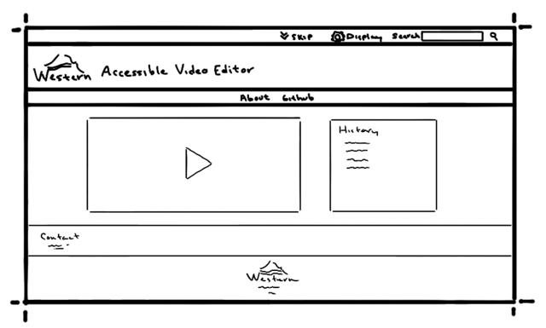The first wireframe depicts the general layout of the web application page for the Accessible Video Editor. The page will utilize Western’s theme and component library Ashlar and its common pattern organisms.

From the top down the page will feature the pre-header with its familiar tools, skip to content, display settings, and search bar. The display settings menu will take full advantage of Ashlar’s accessibility features and eliminate the need for a separate accessibility section within the content of the application.

The Western header will follow which will include the default Western logo and title of the application, “Accessible Video Editor.” Below Western header will be the main navigation containing the “About” and “GitHub” from the original web app.

Below this will be the “content” and will include a redesigned and updated editor that features two inline sections, the video editor section on the left that contains the editor and its related interactions, and an alert and history section. This redesigned text box will now include not just the current alert message, but an in-order history that contains descriptions of page alerts, directions, and actions taken by the user. It is followed beneath by a button that reads, “download history” so that a transcript of what has transpired so far within the editor can be saved and reviewed later.

Below the content section will be Western’s site footer, possibly with contact information or related links and the final section will be the Western footer.

Note that all wireframe depictions include these headers and footers from Ashlar as well as the alert and history section and therefore all following wireframe depictions will assume their inclusion and may describe only the content section that differs from one wireframe to another.

## Choose File

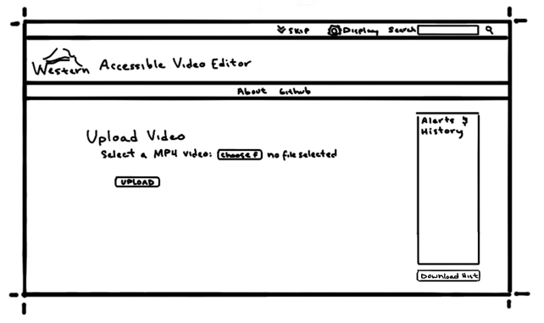The content of Choose File wireframe is the landing page for a new project. It feels and operates very similarly to the original web app. The main content of the page includes the editor section on the left and the alert/history section on the right. The editor section on the left has the title Upload Video, and underneath has text that reads, “Select an MP4 video:” followed by and button that reads “choose file” and ends with text that reads, “no file selected.” This text on the end is the default message when no file has yet been selected from the file explorer. Below this section is another button that reads, “Upload” that is disabled while no file is currently selected. To the right of the editor is the alert and history section described within the abstract.

## Upload File

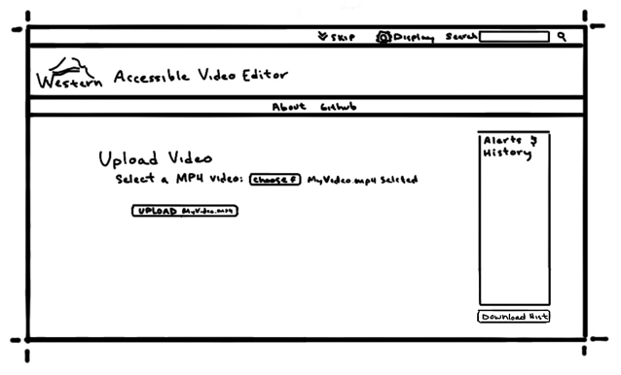After selecting a file, the page changes subtly, working the same way as the original web app. Within the main content of the page, the editor reflects the file selection by replacing the “no file selected” text with “… selected” where the ellipsis is the name of the file selected. In the wireframe example the text reads, “MyVideo.mp4 selected.” The upload button below has also changed to be enabled and clickable and now reads, “Upload MyVideo.mp4.” The alerts and history section remains unchanged in layout but will include the most recent alerts and actions in addition to the previous ones.

## Waiting

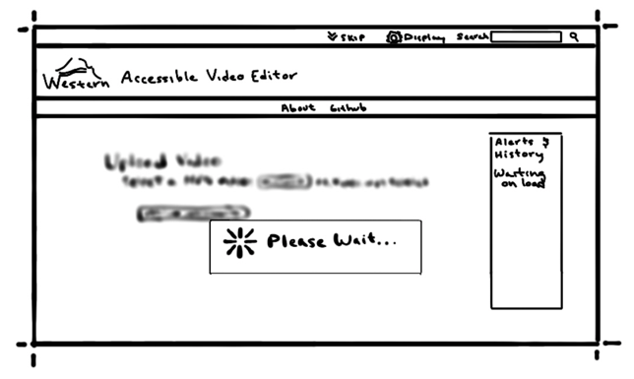Once a file has been selected and the upload button has been pressed, there can be a noticeable hang in the app operation while the file is loaded into the app. This next wireframe called waiting reflects our intention to add some sort of notification to the user that this is a) happening and b) a normal process. The main content of the page now features a blurred version of the editor from the upload file wireframe with a text box overlay that reads “please wait” with an abstract gear symbol. The Alerts and history section also posts an alert notification to notify to the user that reads, “waiting on load.” This way it is clear that the page has not necessarily hung altogether, and the user knows to wait.

## File Loaded

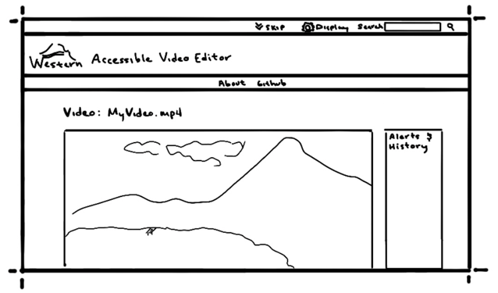Now that a file is loaded the editor section reflects this change by showing a new title of the page which now reads, “Video: MyVideo.mp4,” or whatever the name of the selected video is, and under the title the video editor preview box. To the right of the video preview box is the alerts and history section that has all the same functionality as described previously and although specific messages are not drawn the most recent message will reflect that the file has successfully loaded. As the content within the page is more complex, it was necessary for the content of this part of the app to be spread over several wireframes so that the drawing layout looks proportionally correct. The wireframe drawings depict the page as it is scrolled downward from the top in a few steps. The controls for the video and their details are described in the subsequent wireframes.

## Editor Layout

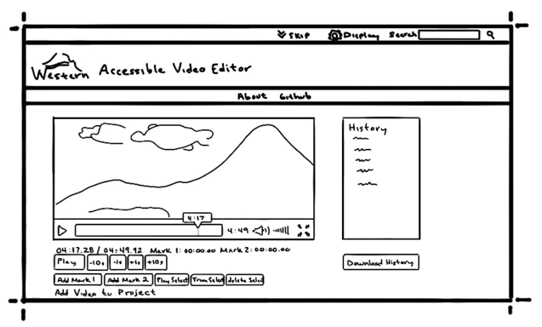The editor is laid out as follows: to the left of the page in the editor section is the video editor preview box and its associated controls below it. The video preview box shows an illustrated version of the moviepy library’s new preview box that provides more control over the version currently used. It includes its own play button, timeline bar, and larger current location pointer that includes the time at the current position, volume controls and an option for full screen. The editor buttons below include the current time the video is at against the total length of the video, the location of the first mark in time, the location of the second mark in time, the player navigation control buttons, and the marking and editing toolset buttons. To the right is the alerts and history pane that shows indecipherable lines that represent the accumulated history of the project that can be reviewed and its associated download button.

## Editing Controls

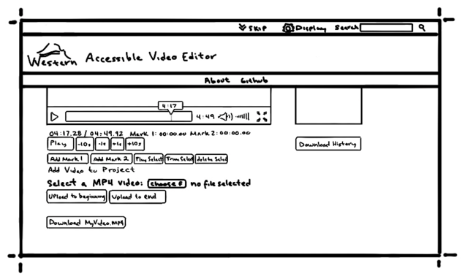There are several editing controls, most of which will be familiar to the original app. As a note, any reference to something listed as a position in time will be displayed in minutes and seconds and accurate to the nearest hundredth of a second.

It will first have the current position in time of the video against the total time of the video. It is then followed by the time of mark 1 and the time of mark 2. Next are player navigation controls which include a play button and additional buttons to move -10s, -1s, +1s, and +10s respectively. Below these are the add mark 1, add mark 2, play selection, trim selection, and delete selection buttons that make up the editing tool controls.

In addition to these we would also like to add additional functionality to the editor in the way of adding additional videos the project that can be stitched together from the beginning or to the end. The wireframe depicts this as a section similar to the select file functionality described in the select file wireframe with a heading that reads, “Add video to project,” the familiar select video layout and mechanic with the notable exception that there are now two buttons to upload the file. One of these buttons reads, “Upload to beginning” and the other “Upload to end.” This would provide the user with greatly improved functionality to create a single video from several others, instead of only being able to edit a single video.